**Design Of Automatic Fire Extinguisher System for Electric Vehicles**

Milan Sonnad1, Mohammed Saqhib1, Mohammed Hussain Khan1, Himanshu Jha1, P. Sudhakar2*

**1UG Graduate, Department of Mechanical Engineering, Dayananda Sagar College of Engineering, Bangalore**

**2AssistantProfessor, Department of Mechanical Engineering, Dayananda Sagar College of Engineering, Bangalore**

*Corresponding Author: Sudhakar-me@dayanandasagar.edu

**Abstract**

Electric vehicles are best alternatives for the internal combustion engine powered vehicles but there is increased concern among people about safety in electric vehicles due to increased number of EV battery fire reports. The growing popularity and adoption of electric vehicles (EVs) have led to an increased need for advanced safety systems, especially in fire prevention and extinguishing. Electric vehicle fires present unique challenges due to the high energy density of their battery packs and the potential for thermal runaway. This study introduces an automated fire extinguisher system specifically designed for electric vehicles, aiming to enhance safety and mitigate fire-related risks.

In this work, design for a system which detects the fire or smoke from batteries of the Electric vehicles and extinguish those fires before it causes huge property damage, injuries, losses and also system to alert rider about the fire so rider can reach safe distance from the vehicle and escape from fatal injuries. This study also aims to minimize the chances of battery explosion and save the vehicle from destruction in case of battery fire.

Table 1. Reasons for EV fire accidents

**Keywords:** Electric vehicle, Battery, Fire, Safety factors, explosions and Prevention.

1. **Introduction**

The rise in air pollution from fossil fuel-driven vehicles and the depletion of fossil fuel reserves have led to a growing demand for alternative energy sources in the automobile industry. Electric vehicles (EVs) are emerging as one of the prominent alternatives to traditional fossil fuel vehicles and have been gaining popularity in recent years. In 2015, approximately 380,000 EVs were produced, and the demand for electric vehicles growing rapidly more than the expected rate.

As the automobile sector in India experiences significant growth in EV adoption, the focus on safety and security becomes increasingly vital. Studies conducted by various organizations indicate a noticeable increase in the number of reported electric vehicle fire accidents. These incidents have caused considerable property damage, injuries, and even casualties due to thermal self-ignition, battery explosions, and fires caused by vehicle batteries. The concerns surrounding the reliability and safety of battery-powered electric vehicles present additional challenges for firefighting and emergency rescue operations. Consequently, numerous research efforts have been undertaken to address the technology of lithium battery fire prevention and control prevention and control were conducted. The fig 1. shows different reasons why Electric Vehicles catch fire. It can be seen that many electric bikes catch fire during charging and many incidents occur at charging stations. There are also many other reasons for this as mentioned improper wiring can also result in this. It can also consider accidents as main reason during collision the disturbances in battery can cause fire [1].

The objective of this study is to design an automatic fire extinguishing system using CATIA software and a program coding to detect battery temperature using Arduino software was carried out. With considering all the reasons mentioned in fig1., the study

|  |  |
| --- | --- |
| **Why EVs Catch Fire** | |
| Short circuit | A short circuit brought about from a wiring fault to even a puncture in the cells can cause a rise in temperature and subsequently a fire. |
| Faulty charging | Using incorrect and/or faulty cables or wall outlets can also trigger a fire with an incorrect amount of electricity |
| Cell quality | Even a single contaminated cell can spark a massive fire, igniting itself and then leading to the dreaded thermal runway igniting subsequent cells thanks to the temperature rise. |
| BMS issues | The key safety task in any battery management system (BMS) is temperature control. This entails carefully managing both charge and discharge speed and cycles, any fault here can raise the battery temperature sufficient enough to combust and high ambient temperatures exacerbate the issue. |
| Accidental damage | Though protected very well, a battery getting punctured or even dented in an accident can lead to cell ruptures and thus ignition. An accident can also spill oil - yes EVs have oil for lubrication and cooling - onto hot electrical components which can ignite and lead to a bigger blaze |

aims that it can prevent from property damage, injuries and improve safety.

In consideration of fire in battery of EV, two types of fire namely Class B and C are present in this fire detection in lithium batteries and their brief information of each fire is listed below:

#### Class B Fire:

Class B fires are ignited by flammable liquids or gases such as alcohol, kerosene, paint, gasoline, methane, oil-based coolants, or propane. Water is ineffective for extinguishing Class B fires. Instead, Carbon Dioxide (CO2) or dry chemical agents are typically used to combat these fires.

#### Class C Fire:

Class C fires are characterized by live electrical currents or electrical equipment as their source of fuel. These could include electric tools, appliances, motors, and transformers. Such fires are prevalent in industrial settings dealing with energy or electrically powered equipment, such as wind turbines. Water is unsuitable for fighting electrical fires and can worsen the situation. Non-conductive chemical agents, including clean agents, are recommended for extinguishing the flames [2].

|  |  |
| --- | --- |
| Nominal Capacity | 24 Ah |
| Capacity | 24 Ah |
| Nominal Voltage | 60 V |
| Maximum Charging Current | 5 Amp |
| Warranty | 2 yrs. |
| Model Name/Number | IQube |
| Minimum Order Quantity  Table 2. Battery specification  c | 1 |

In this case, the study deals with an Iqube (TVS make) bike battery with a capacity of 24Ah and battery details are stated in table 1.

1. **Fire Suppression agents for Battery fire**

Table 2 shows some of the fire suppression agents and its effectiveness to the fire. This indicates that various compounds have various suppressing effects and that various agents are effective for various battery kinds. In some agents the re-ignition which might be danger sometimes. So, careful consideration of parameters related to selection of agent which is used in the system [2]

|  |  |  |  |
| --- | --- | --- | --- |
| **Agent** | **Battery type** | **Release moment** | **Suppression effectiveness** |
| CO2 | LiNi03Co­­­0.2 Mn0.3O2/Graphite | Safety valve is opened | It took 30sec to suppress the fire but reignition was observed during releasing |
| HFC-227ea | LiNi03Co­­­0.2Mn0.3O2/Graphite | Safety valve is opened | It took 22 s to suppress the fire, but re-ignition was observed during the releasing |
| Water mist | LiNi03Co­­­0.2Mn0.3O2/Graphite | Safety valve is opened | No flame appeared |
| Water | Ni oxide/graphite | Temperature of battery up to 650 "C | Extinguished fire within 20 s |
| CO2 | Ni oxide/graphite | Temperature of battery up to 650 "C | Having no effect on reduced the temperature |
| Foam | Ni oxide/graphite | Temperature of battery up to 650 "C | Extinguished fire within 20 s |
| Water mist | Ni oxide/graphite | Temperature of battery up to 650 "C | No effect on reducing the temperature |
| Dry power | Ni oxide/graphite | Temperature of battery up to 650 "C | No effect on reducing the temperature |
| CO2 | LFP | Battery occurs fire | Re-ignition happened |
| HFC-227ea | LFP | Battery occurs fire | Suppressed the fire Explosion and thermal runaway occurred |
| Super fine power | LFP | Battery occurs fire | Explosion and thermal runaway accord |
| CO2 | 13S5P 18650-TYPE LiCoO2 Cell | 15 s after fire occurred | Re-ignition occurred at 10 s after the suppression of open fire |
| Dry powder | 13S5P 18650-TYPE LiCoO2 Cell | 15 s after fire occurred | Re-ignition occurred at 8s after the suppression of open fire |
| 3% AFFF | 13S5P 18650-TYPE LiCoO2 Cell | 15 s after fire occurred | Re-ignition occurred at 45 s after the suppression of open fire |
| Aqueous agent | 5 18650-type UBs | First battery occur TR | None of the cells propagated |
| Gaseous agent | 5 18650-typ e UBs | First battery occur TR | All of the cells propagated |

1. **Materials and methods**

**The Automatic fire extinguisher system for EVs has following components,**

* Arduino UNO
* MQ 2 sensor
* RTD Sensor (temperature sensor)
* Solenoid valve
* Pressure cylinder for CO2
* IR flame sensor

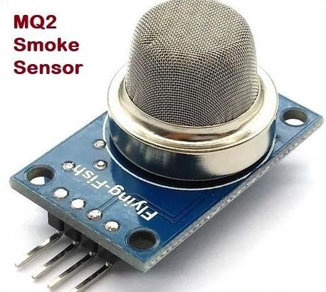

Fig 1. MQ2 smoke sensor

1. **Arduino Uno**

The Arduino Uno is a microcontroller board based on the Microchip ATmega328P microcontroller (MCU) and it is an open-source platform equipped with sets of digital and analog input/output (I/O) pins, enabling connections to various expansion boards (shields) and circuits. The board features 14 digital I/O pins, with six of them capable of PWM (Pulse Width Modulation) output, and 6 analog I/O pins. For programming the Arduino Uno, Arduino IDE (Integrated Development Environment) with a type B USB cable is used in this study. Power can be supplied through either a USB cable or a barrel connector that supports voltages between 7 and 20 volts, like a rectangular cross section 9-volt battery.

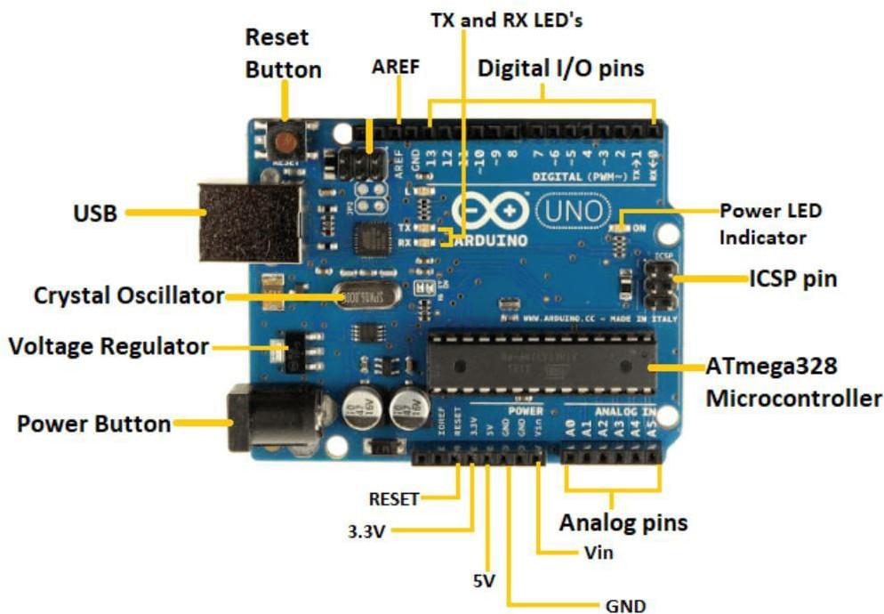

Fig. 2. Parts of Arduino UNO

1. **MQ2 Smoke Sensor**

The Fig. 3 shows MQ2 smoke sensor, belonging to the family of MQ sensors, operates based on Metal Oxide Semiconductor (MOS) technology. It requires a 5V DC supply and consumes approximately 800mW of power. This sensor can detect various gases, including smoke, hydrogen, alcohol and carbon monoxide with concentrations ranging from 200 to 10,000 parts per million.

1. **RTD sensor**

A RTD (Resistance Temperature Detector) is a temperature sensor that exhibits a change in resistance corresponding to fluctuations in temperature. Fig. 4 shows the sensor used here. This resistance-temperature relationship is widely understood and remains consistent over time, ensuring repeatability. It's important to note that an RTD functions as a passive device.

Table 3. Different fire suppression agents for different batteries

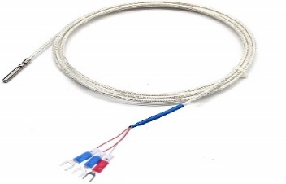

Fig 3. RTD Sensor

1. **Solenoid Valve**

Application of the solenoid valve maintains flow of CO2, the valve product name is BRANDO SH as shown in fig. 5 and the details are mentioned below.

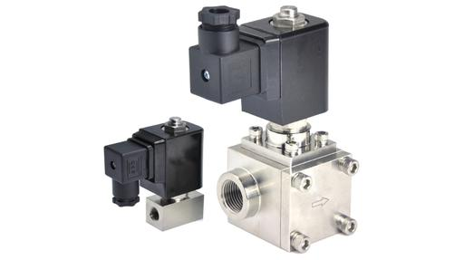

Fig 4. 160 Bar High pressure stainless-steel solenoid valve

Specifications of valve**:**

1. Make/manufacturer: BRANDO
2. Model no: SH
3. Working medium: air, water, gas, liquid, etc
4. Max Working Pressure: 160 bar
5. Seal Material: PTFE
6. Body Material: Stainless Steel 304
7. Port Size: 3/8'', 1/2'', 3/4'', 1''
8. Orifice Size: 1mm to 25mm
9. Operation: Direct Acting (DN1 to 5), Piston Pilot Operated (DN10 to 25)
10. Voltage: 12VDC, 24VDC, 24VAC, 110VAC, 220VAC (50/60Hz)

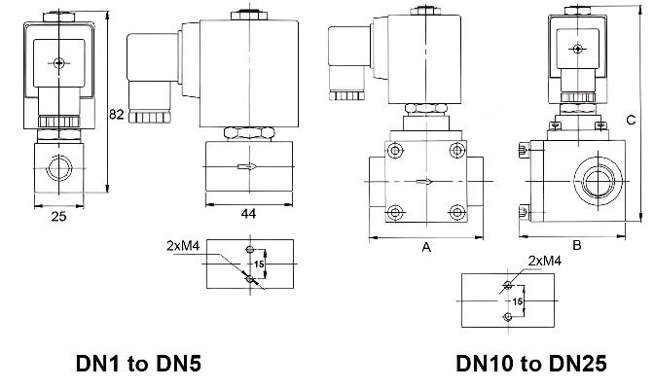

Fig 5. Technical Data of valve

1. **Pressure cylinder for CO2**

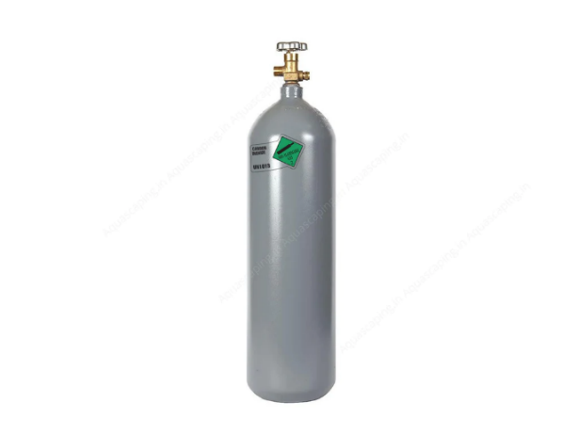

Fig 6. Pressure cylinder for CO2

Fig. 7 shows bulk low-pressure carbon dioxide and high-pressure canister CO2.

Material and Weight: CO2 bulk tanks and cylinders are available in various sizes depending on their intended use, and the two most common materials used are aluminum and steel. The weight of these tanks differs based on their material and whether it is empty or filled. Bulk tanks are stationary and typically constructed from 100% stainless steel, and are prepared in various sizes to suit specific requirements. The size and capacity offer increased distribution flexibility and reduce the need for frequent refilled cylinders. On the other hand, CO2 canisters or cylinders are high-pressure tanks designed for exchange of fluid. It is weighed over 100 lbs when empty and up to 200 lbs when filled.

1. **Prototype design for fire extinguishing system**

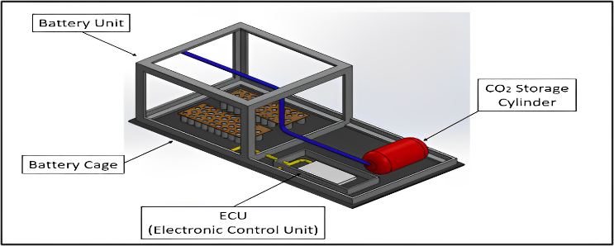

Fig 7. Prototype design

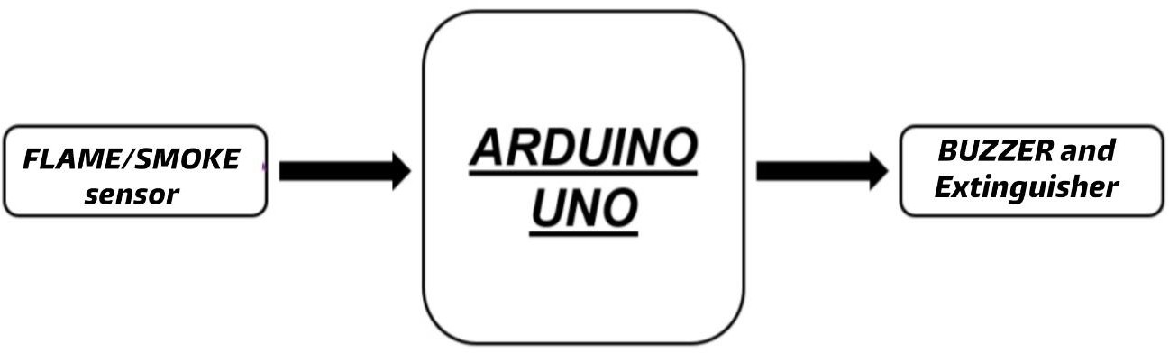

Fig 8. working principle

Various components, such as the flame sensor, gas sensor, buzzer, and water pump, are connected to the Arduino using jumper cables (fig. 10). These sensors and components are linked to their respective pins, as specified in the program that was uploaded to Arduino. Power for the Arduino board comes from a laptop, while the other components receive power from the 5V pin on the Arduino.

The IR flame sensor and MQ2 gas sensors continuously monitor for the presence of flames or smoke near the battery. If either sensor detects flame or smoke, it sends a value of 1 to the Arduino, indicating the presence of fire or smoke. The Arduino, in turn, triggers the buzzer, and the water pump floods the battery compartment with water until the fire is extinguished.

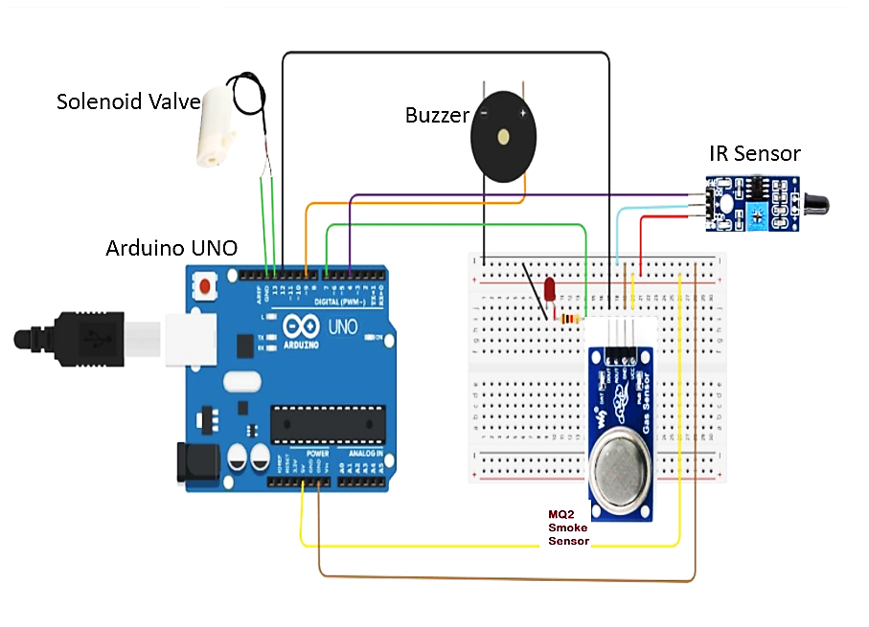

Fig 9. Circuit diagram

The design of the automatic fire extinguisher system is intended for the “IQube”, which features a 3.04kWh Lithium-Ion battery with a curved shape. The structure is constructed using materials capable of withstanding higher temperatures and is less prone to catching fire, unlike steel. The design incorporates breathing holes to facilitate battery cooling. The flame sensor has an effective range of 30cm, and smoke sensors are strategically placed in each corner, approximately 50cm apart from one another, mainly oriented towards the terminals to cover the entire battery area as seen in fig. 8. In the event of flame or smoke detection, the buzzer and solenoid valve are activated as seen in fig 9, allowing the flow of AVD (Automatic Vapor Dispenser) stored in the boot space. Within 25 seconds of detection, the curved structure is flooded with AVD, preventing further damage to components, and avoiding battery explosions.

1. **Results and Discussion**
   1. **Results**
      1. **IR sensor output**

The output of an IR (infrared) sensor can vary significantly depending on its specific type. It will manifest in various forms, such as digital signals that signify the presence or absence of an object. Analog signals that correspond to the intensity of detected infrared radiation, pulse width modulation (PWM) signals that change based on proximity or intensity, or serial communication protocols that offer detailed information, including calibrated values or distance measurements. To successfully integrate an IR sensor with microcontrollers or other electronic components for further processing and decision-making, it is crucial to consult the sensor's datasheet or relevant literature.Fig. 11 shows the temperature variation for the given period of time. The reference value for initiation of flame considered is 1500 C, it is seen in the fig. 11 the designed system detects in 20 seconds. Maximum upper limit and minimum upper limit is 160 and 1060 C in the temperature management of fire detection is considered.

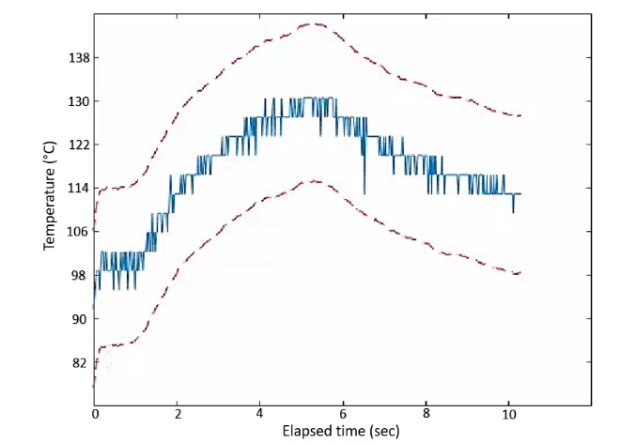

Fig 10. Temperature sensor output readings

* + 1. **MQ2 sensor output**

The MQ2 smoke sensor will detect the presence of smoke or flammable gases within a range of 300 ppm to 10000 ppm. Its output typically takes the form of an analog signal, with variations in voltage or current proportional to the quantity of smoke or flammable gases detected. Higher concentrations of smoke or gas leads to an increase in the output signal, while lower concentrations result in a decrease in signal strength. In areas where there is a potential risk of smoke or combustible gases, this analog output can be further processed or utilized in conjunction with microcontrollers or other electronic devices to trigger alarms, activate safety features, or assess the air quality.

**5.2 Discussions**

In the realm of fire suppression, innovative solutions tailored specifically for electric vehicles (EVs) are emerging. These solutions encompass various methods such as foam, inert gases, water mist, and even solid-state extinguishing substances. In comparison to traditional fire suppression systems, these cutting-edge technologies offer numerous advantages, including enhanced effectiveness in extinguishing battery fires, reduced environmental impact, and simplified installation and maintenance processes. The integration of fire suppression systems with other vehicle safety features is a possibility in the future. This could involve combining them with existing safety mechanisms like airbags and battery management systems. Such connectivity would enable the fire suppression system to activate automatically in the event of a fire or be manually triggered by the driver or passenger during emergency situation [4].

As EV technology continues to gain wider adoption, it becomes imperative to establish new criteria for EV fire safety. These standards must account for the diverse range of fire suppression devices available and consider the unique characteristics of EV batteries. By doing so, it is ensured the utmost safety and protection as electric vehicles become more prevalent on the roads.

1. **Conclusion**

After conducting an extensive review of various literature papers and developing an automatic fire extinguisher system for electric vehicles, the study arrives the conclusion that the designed model exhibits excellent capabilities in detecting and extinguishing fires. Moreover, it can be seamlessly integrated into production electric vehicles, thereby significantly reducing the occurrence of electric vehicle fire accidents. The inclusion of infra-red flame sensors and MQ2 smoke sensors ensures a swift response to battery fires. In the event of a fire, these sensors will promptly trigger the fire extinguisher system and alarm, effectively containing the fire's spread, minimizing component damage, and reducing the risk of explosions. The alarm system serves as a crucial warning mechanism, alerting riders and bystanders to evacuate to a safe distance before any potential dangers escalate. To ensure continuous monitoring of battery temperature, a temperature sensor module is incorporated. In situation where battery's temperature exceeds a certain threshold, indicating a high likelihood of fire or explosion, the system takes preventive measures. It immediately disconnects the battery from circuits and charging to prevent any potential fire, and the cooling system is activated to mitigate temperature rise [2].

In the literature, Advanced vehicle diagnostics (AVD) was mentioned as the most efficient fire extinguishing agents for lithium-ion battery fires, though a complexion in design, intended not to include them in this field of study. Also, several reasons integrated for excluding AVD in design for eliminating increasing complexity, programming requirements, and associated component costs. Nonetheless, the designed system with its array of sensors and fire extinguishing mechanisms is proven to be highly effective and addresses the critical need for enhanced fire safety in electric vehicles.

**Reference**

[1] David Wagman, powerplant run on CO2, June-2018.

[2] Torgrim Log, Peter Cannon-Brookes, Water mist for fire protection of historic buildings and museums, Museum Management and Curatorship, 14(3), pp. 283- 298 (1995)

[3] Liao Guangxuan, Huang Xin, Cong Beihua, Qin Jun, Liu Jianghong, Wang Xishi, Progress in water mist fire suppression technology, Journal of University of Science and Technology of China; 36(1), pp. 9- 19 (2006)

[4] Wang Xishi, Liao Guangxuan, Qin Jun and Fan Weicheng, Experimental study on effectiveness of extinction of a pool fire with water mist, Journal of Fire Sciences. 20(4), pp. 279-295. (2002)

[5] Wu Longbiao,Fang Jun,Xie Qiyuan. Fire detection and information processing[M]. Beijing: Chemical Industry Press, 2006, 264-265(in Chinese)

[6] Chen nan. Design of Fire Detection and Control Systems for Intelligent Buildings[M]. Beijing: Tsinghua University Press, 2001, 7: 19-60(in Chinese).